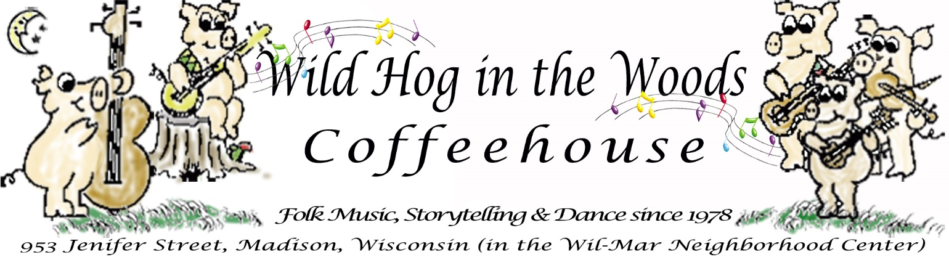
PRESS RELEASE
Wild Hog in the Woods Coffeehouse Reopens at the
Wil-Mar Neighborhood Center After Remodel

Contact: Jamie Diana Poindexter  Phone: (608) 770-8092 (leave a message if not answered)  Email: jamiep@wildhoginthewoods.org | FOR IMMEDIATE RELEASE  October 25, 2019

Madison, Wisconsin - The Wild Hog in the Woods Coffeehouse will present our first Friday evening folk concert at the recently remodeled Wil-Mar Neighborhood Center on Friday, November 1. Casey Day, who performed his first solo concert on our stage in 1984, returns to play traditional and contemporary folk along with some Irish ballads. Doors open at 7:00 PM, concert begins 7:30 PM. Admission is $4 public, $2 members. 953 Jenifer Street (entrance on Brearly Street), Madison, Wisconsin.

Also, our Grand Reopening Party will be the evening of Friday, November 22 in conjunction with our 41st Anniversary. Admission is free. We are planning the details but do expect some live music and probably some dancing, along with refreshments and a birthday cake celebrating the Wild Hog’s 41st birthday.

PreSS KIT available
This press release and a selection of high resolution photos available at: www.wildhoginthewoods.org/PressReleases

About the Wild Hog in the Woods Coffeehouse
Founded on University Avenue in 1978, the Wild Hog in the Woods moved to the Wil-Mar Neighborhood Center in 1992, this is the first major remodel the building has had since. Earlier this year, Wil-Mar was picked to receive a makeover by “Design for a Difference”, a philanthropic effort of Floor360, an interior design firm. During the remodel, the Wild Hog in the Woods held our Friday evening concerts at Wil-Mar’s temporary location on East Main and Brearly Streets.

“The temporary location worked for us and had good acoustics, but we look forward to moving back into the remodeled Yahara Room at Wil-Mar. The Design team did an excellent job meeting the Hog’s needs for lighting and storage so we can provide that 60’s style folk music environment that the Hog is known for”, stated Jamie Poindexter, a member of the Wild Hog’s Coordinating Committee.

The Wild Hog in the Woods (“the Hog”) operates a 60’s style coffeehouse with live folk music and other special events, workshops and dances, sometimes in cooperation with other organizations. The Hog is a membership organization, a 503(c)3 not for profit based on cooperative principles that was started by musicians in 1978. Members play an important role in the Wild Hog, volunteering their time to host the coffeehouse and other events, including promotion, booking performers, running sound, baking, newsletter, web site, and much more.

Web site: www.wildhoginthewoods.org
-End-

